Progressive Report

Dingming

1. Background

The target of analysis is switched to focus on simpler indicators and some findings based on these indicators:

**Retrace Date: the date when the price reaches maximum/minimum**

**Peak Gain/Trough loss: Peak gai/Trough loss from day0**

**Recover Date: the date when the price recovers to day0**

**Recover Rate: the percentage of stocks which can recover to day0**

**Monotonic Rate: the percentage of stocks which have monotonic trends**

1. Data

I set the model as the following parameters:

1. Observe **20** days after earnings
2. Earnings over **10%** beat and over **10%** miss are calculated
3. **Semiconductor**, **59** stocks in total, U.S(**19**), EU(**13**), Asia Pacific Developed(13), Asia Pacifica Merging(**14**), All selected stocks are among the top-ranked by market capitalization.
4. Results

**Distribution of the four situations**

The distribution of the four situations are shown in this figure:

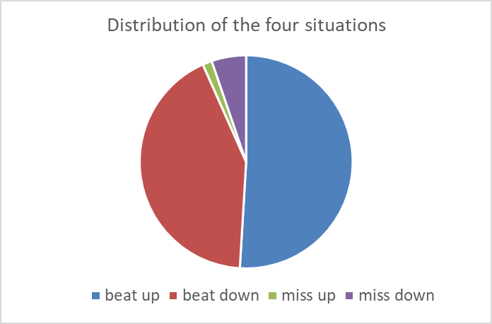



Beats are 10 times more than misses. There’s almost no miss up in semi-conductor.

Beat up has higher monotonic rate, indicating that the stock is more likely to continuously increase without dropping in this situation.

**Number of days to retrace**

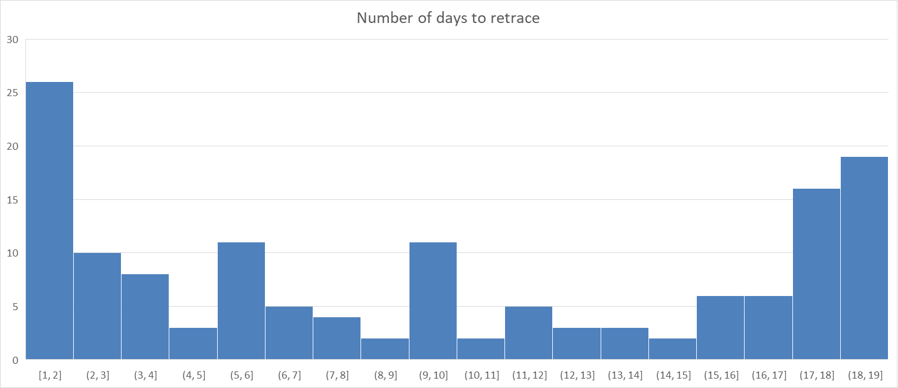

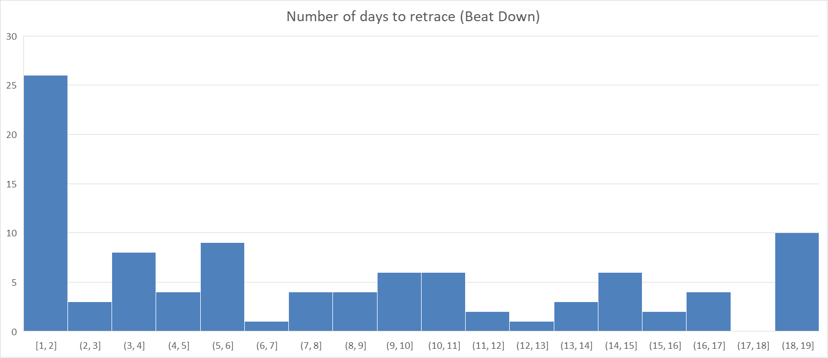

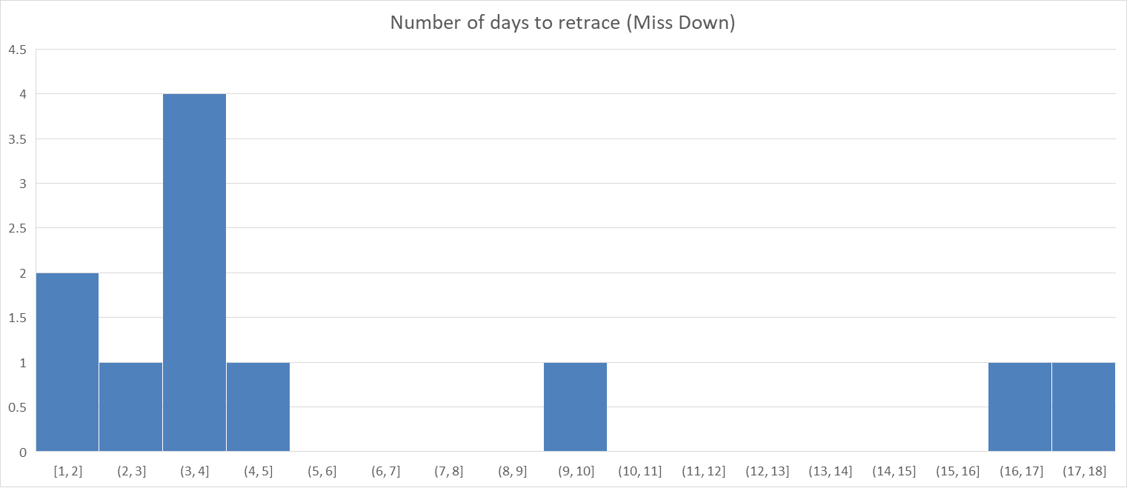

From the figure of beat-up, it can be observed that there are 3 peaks. It indicates that if the stock price does not retrace after day1 or day2, it is more likely to retrace on day 6, then day 10.

For Beat-down situation, the stock is more likely to retrace on day1 or day2 after earnings. The number of miss-up is so small that contains little reference meanings. For miss-down, retrace is more likely to happen on day 4.

The red square shows that beats within this square reach their maximum price around day 18-20, suggesting that these beats are monotonically increasing (the outliers that we have previously discussed). In the following calculation and the analysis, I eliminated these outliers and only calculate those who “actually retrace”

**Peak Gain & Trough Loss**

The average Peak Gain/Trough Loss is calculated based on the retrace date. The result is as shown in the following figure. The first figure is for beat up and the second is for miss down.



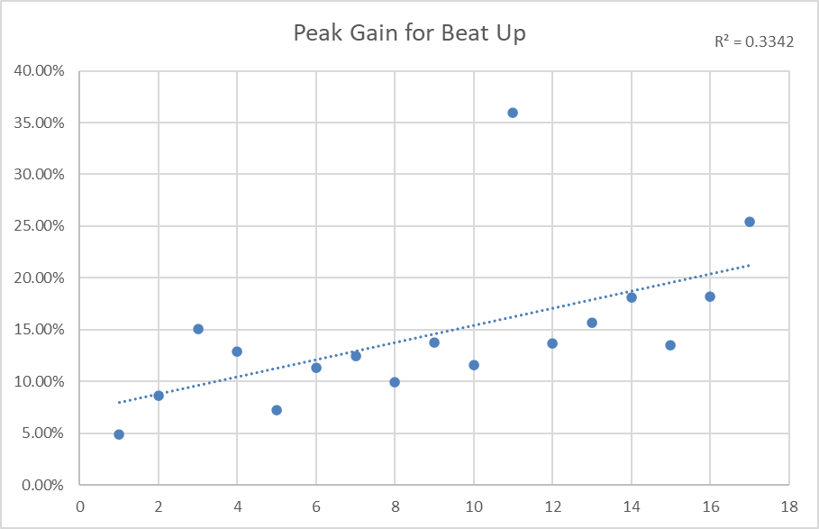

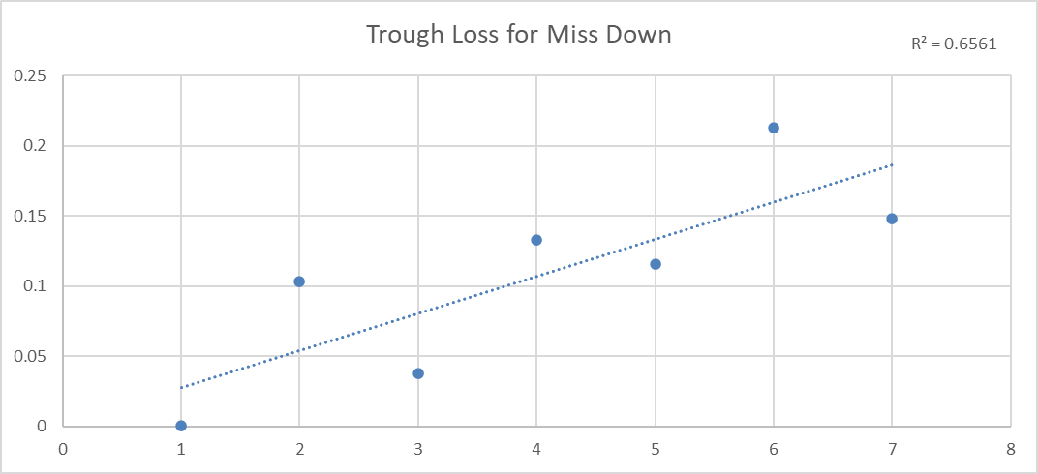

The average Peak Gain and Trough Loss shows linear relationship with retrace date. It offers us some reference meaning to determine whether the stock would retrace certain days after the earnings. For example, in beat up situation if a stock continuously show lower gain than the average level, then we could suppose that this stock has high possibility to retrace at any time.

**Recover Rate & Recover Period**

The recovery rate of beat up is 49.53%, 56.18% for beat down and 54.55% for miss down. It indicates that half of the stocks will recover within 20 days.

I compare the retrace date and how long does it take to recover to day0(recover period). There’s a slightly linear relationship between recover period and retrace date. When the retrace date is longer, it usually takes longer time to recover. An estimate can be made to predict how long it would take to recover when the stock starts to retrace.

